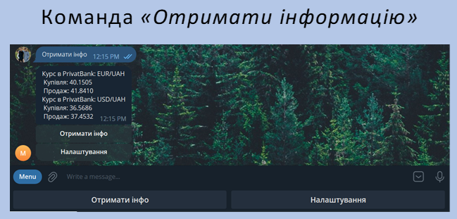

private static final String RESPONSE_TEMPLATE = "Курс в банку: cur1/UAH\n Купівля: покуп\n Продаж: прод\n";  
private static List<CurrencyRate> currencyRateList;  
public static String showInfo(SettingsUserDto settingsUserDto) {  
 String res;  
 String bankName = formatBankName(settingsUserDto.getBankName());  
 String formatDecimalPoint = formatDecimalPoint(settingsUserDto.getDecimalPoint());  
 res = currencyRateList.stream()  
 .filter(item -> settingsUserDto.getCurrency().contains(item.getCurrency()))  
 .map(item -> RESPONSE_TEMPLATE  
 .replace("cur1", item.getCurrency().toString())  
 .replace("покуп", String.format(formatDecimalPoint,item.getBuyRate()))  
 .replace("прод", String.format(formatDecimalPoint,item.getSellRate()))  
 .replace("банку", bankName))  
 .collect(Collectors.joining());  
 return res;  
}  
  
private static String formatDecimalPoint(DigitsAfterDecimalPoint digitsAfterDecimalPoint){  
 switch (digitsAfterDecimalPoint){  
 case TWO:  
 return "%.2f";  
 case THREE:  
 return "%.3f";  
 case FOUR:  
 default:  
 return "%.4f";  
 }  
}  
  
private static String formatBankName(BankName bankName){  
 switch (String.valueOf(bankName)) {  
 case "NBU":  
 currencyRateList = HourCurrencyRatesUpdate.currencyRateNBUList;  
 return "НБУ";  
 case "MONOBANK":  
 currencyRateList = HourCurrencyRatesUpdate.currencyRateMonoList;  
 return "MonoBank";  
 case "PRIVATBANK":  
 default:  
 currencyRateList = HourCurrencyRatesUpdate.currencyRatePrivatList;  
 return "PrivatBank";  
 }  
}